Lesson 7: Quadratic & Polynomial Functions
Math 2412 Precalculus · Unit 2: Polynomial, Rational, Exponential & Logarithmic Functions · Student Guided Notes
Name: ______________________________ Date: ______________

Lesson objective
Students will write quadratic functions in standard form, find the vertex and maximum or minimum value, describe end behavior, find zeros and their multiplicities, and sketch polynomial graphs.

Before class
Complete these short tasks before the lesson. They review skills this lesson builds on.
- Factor $x^{2}+2x−8$ and $x^{3}−9x$ (Lesson 1).
- Solve ${(x−5)}^{2}=17$ (Lesson 2).
- Expand ${(x−3)}^{2}$. What number must be added to $x^{2}−6x$ to make a perfect square trinomial?
- Describe how the graph of $y=−2{(x+3)}^{2}+1$ is transformed from $y=x^{2}$ (Lesson 5).

Skill 7.1: Quadratic Functions in Standard Form

Key ideas
- General form: $f(x)=ax^{2}+bx+c$ with $a≠0$.
- Standard (vertex) form: $f(x)=a{(x−h)}^{2}+k$. The vertex is ______________ (1) and the axis of symmetry is the line ______________ (2).
- If $a>0$ the parabola opens ______________ (3) and k is the minimum value. If $a<0$ it opens ______________ (4) and k is the maximum value.
- y-intercept: $f(0)$. x-intercepts: solve $f(x)=0$.

Steps: complete the square
- If $a≠1$, factor a out of the $x^{2}$ and x terms only.
- Take half of the x-coefficient inside the parentheses and square it.
- Add that number inside the parentheses, and subtract a times that number outside, so the function does not change.
- Write the perfect square trinomial as a squared binomial and combine the constants.

Example 1: $f(x)=x^{2}−10x+8$
Half of −10 is −5, and ${(−5)}^{2}=25$: $f(x)=(x^{2}−10x+25)+8−25={(x−5)}^{2}−17$.
- Vertex (5, −17); $a=1>0$, so the minimum value is −17.
- y-intercept: $f(0)=8$.
- x-intercepts: ${(x−5)}^{2}=17$, so $x=5±\sqrt{17}$, about 0.88 and 9.12.
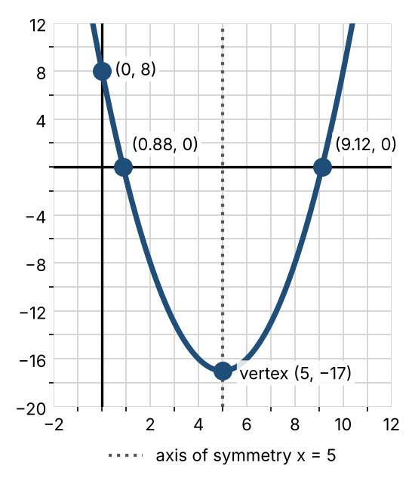

Example 2: $f(x)=2x^{2}−12x+13$ (a ≠ 1)
Factor 2 from the first two terms: $f(x)=2(x^{2}−6x)+13$. Half of −6 is −3, and ${(−3)}^{2}=9$.
$f(x)=2(x^{2}−6x+9)+13−2·9=2{(x−3)}^{2}−5$. Vertex (3, −5), minimum value −5.
Watch out: the 9 was added inside parentheses that are multiplied by 2, so $2·9=18$ must be subtracted outside.

Practice
a. Write $f(x)=x^{2}+2x−8$ in standard form. Find the vertex, the intercepts, and the minimum value. Sketch.  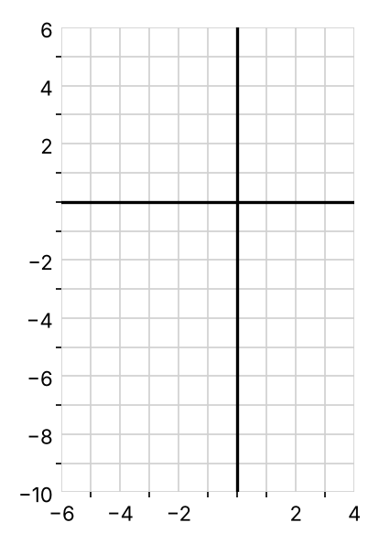 | b. Write $f(x)=−x^{2}+4x+5$ in standard form. Find the vertex, the intercepts, and the maximum value. Sketch.  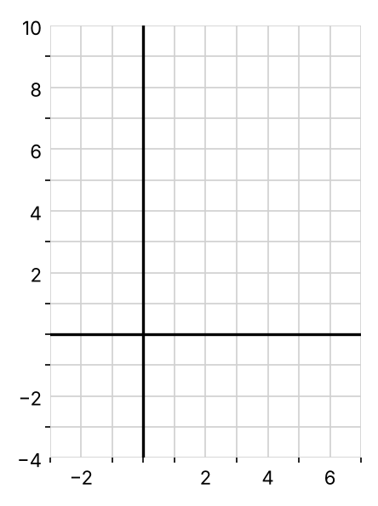
c. Write $f(x)=5x^{2}+30x+4$ in standard form and find the vertex.

Skill 7.2: The Vertex Formula & Applications

Key ideas
- For $f(x)=ax^{2}+bx+c$, the vertex is at $x=−\frac{b}{2a}$. The y-coordinate is $f(−\frac{b}{2a})$.
- To write a quadratic from its graph, use $f(x)=a{(x−h)}^{2}+k$ with the vertex, then substitute one more point to find a.
- In an application, the vertex gives the ______________ (5) or ______________ (6) value of the quantity.

Example 1: $f(x)=−3x^{2}+6x+1$
$h=−\frac{6}{2·(−3)}=1$ and $k=f(1)=−3+6+1=4$. Vertex (1, 4). Since $a=−3<0$, the maximum value is 4.

Example 2: write the equation from a graph
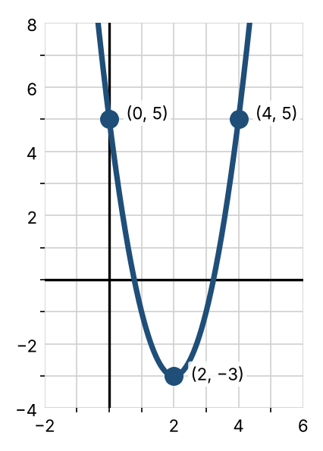
Vertex (2, −3): $f(x)=a{(x−2)}^{2}−3$. The point (0, 5) gives $5=a{(0−2)}^{2}−3$, so $4a=8$ and $a=2$. So $f(x)=2{(x−2)}^{2}−3$.

Example 3: maximum height
A ball's height in feet after t seconds is $h(t)=−16t^{2}+64t+5$. The vertex is at $t=−\frac{64}{2·(−16)}=2$, and $h(2)=69$. The maximum height is 69 feet, 2 seconds after the throw.

Practice
a. Find the vertex of $f(x)=2x^{2}−8x+3$. Is it a maximum or a minimum? | b. Find the vertex of $f(x)=−x^{2}−6x+1$. Is it a maximum or a minimum?
c. Write the equation of the parabola shown.  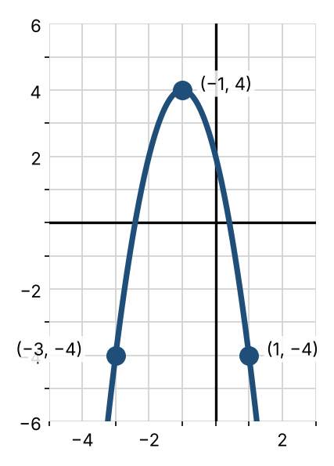 | d. A rectangle has a perimeter of 100 feet. Find the dimensions that give the largest area, and the largest area.

Skill 7.3: Power Functions & End Behavior

Key ideas
- A polynomial of degree n is $P(x)=a_{n}x^{n}+⋯+a_{1}x+a_{0}$ with $a_{n}≠0$. Its graph is smooth and unbroken.
- Even powers ($x^{2},x^{4},x^{6}$) have a U shape: both ends go ______________ (7). Odd powers ($x,x^{3},x^{5}$) go down on the left and ______________ (8) on the right.
- Higher powers are flatter near 0 and steeper when $\left|x\right|>1$. All pass through (0, 0) and (1, 1).
- End behavior describes what happens to $P(x)$ as $x→∞$ and $x→−∞$. It matches the leading term $a_{n}x^{n}$.
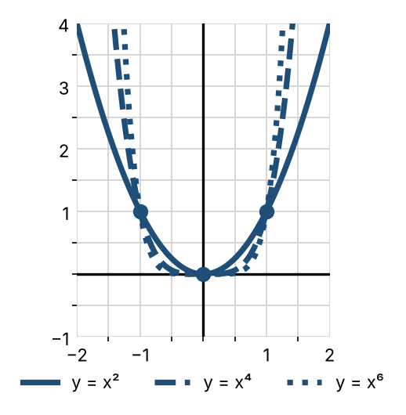 | 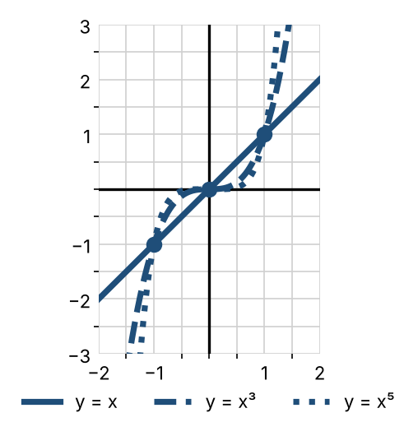

The leading-term test
Leading term | n even | n odd
$a_{n}>0$ | Up on both ends | Down on the left, up on the right
$a_{n}<0$ | Down on both ends | Up on the left, down on the right

In symbols: for $P(x)=2x^{3}−5x$, as $x→∞$, $P(x)→∞$, and as $x→−∞$, $P(x)→−∞$.

Example: $f(x)={(x+2)}^{4}−16$
Shift $y=x^{4}$ left 2 and down 16. The point (0, 0) moves to (−2, −16), and (±1, 1) move to (−3, −15) and (−1, −15). x-intercepts: ${(x+2)}^{4}=16$, so $x+2=±2$ and $x=0$ or −4.
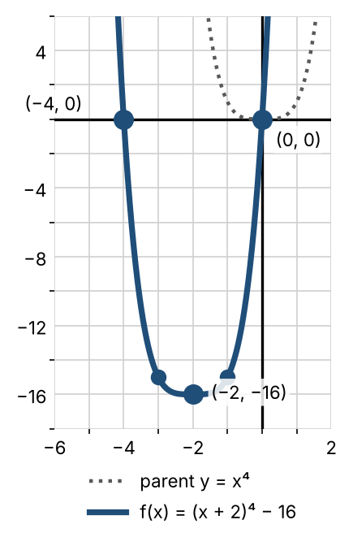

Practice
a. Describe the end behavior of $P(x)=−2x^{5}+x^{2}$. | b. Describe the end behavior of $P(x)=3x^{4}−x^{3}+7$.
c. Sketch $f(x)=x^{4}−16$ by transforming $y=x^{4}$.  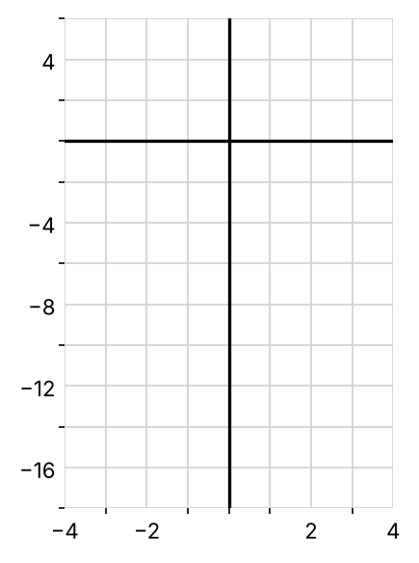 | d. List the transformations of $y=x^{4}$ that give $f(x)=−2{(x+2)}^{4}−16$, and describe its end behavior.

Skill 7.4: Zeros & Multiplicity

Key ideas
If P is a polynomial and c is a real number, these statements all say the same thing:
- c is a ______________ (9) of P.
- $x=c$ is a ______________ (10) of the equation $P(x)=0$.
- ______________ (11) is a factor of $P(x)$.
- (c, 0) is an ______________ (12) of the graph of P.
- If ${(x−c)}^{m}$ is a factor and m is as large as possible, c is a zero of ______________ (13) m.
- Odd multiplicity: the graph ______________ (14) the x-axis at c (flattening out when $m≥3$).
- Even multiplicity: the graph ______________ (15) the x-axis at c and turns around.
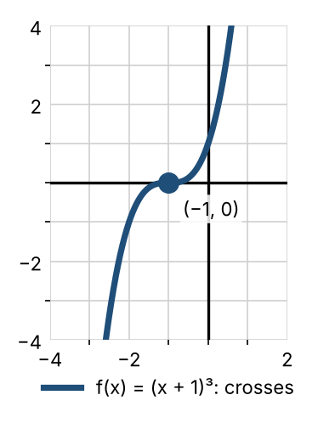 | 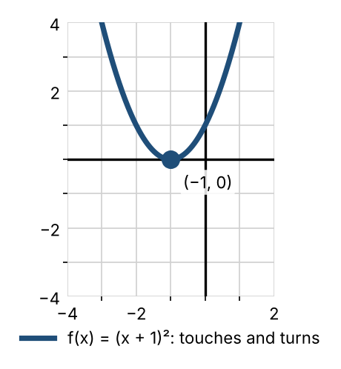

Example 1: $P(x)=(x−1)(x+2)$
Zeros 1 and −2; solutions of $P(x)=0$: 1 and −2; factors $x−1$ and $x+2$; the graph crosses the x-axis at (1, 0) and (−2, 0).

Example 2: $f(x)={(x+1)}^{3}{(x−2)}^{2}$
−1 has multiplicity 3 (crosses, flattening out) and 2 has multiplicity 2 (touches). y-intercept: $f(0)=1^{3}·{(−2)}^{2}=4$.

Example 3: factor to find the zeros of $P(x)=x^{3}+2x^{2}−8x$
$P(x)=x(x^{2}+2x−8)=x(x+4)(x−2)$. The zeros are 0, −4, and 2, each with multiplicity 1.

Practice
a. List each zero of $f(x)=x^{2}{(x−4)}^{3}(x+1)$, its multiplicity, and whether the graph touches or crosses. | b. Find the zeros of $P(x)=x^{3}−9x$.
c. Find the zeros of $P(x)=x^{4}−2x^{3}+x^{2}$ and their multiplicities. | d. Find the intercepts of $P(x)=(x−2){(x+1)}^{2}$.

Skill 7.5: Sketching Polynomial Graphs

Steps: sketch a polynomial
- End behavior: find the degree (the sum of the multiplicities) and the sign of the leading coefficient.
- Zeros: factor, then list each zero with its multiplicity (cross or touch).
- y-intercept: find $P(0)$.
- Test points: find P at an x-value between each pair of zeros to see if the graph is above or below the axis.
- Sketch a smooth curve. A polynomial of degree n has at most ______________ (16) turning points.

Example: $P(x)={(x−1)}^{2}{(x+2)}^{3}$
- Degree $2+3=5$, leading coefficient 1: down on the left, up on the right.
- Zeros: −2 (multiplicity 3, crosses and flattens) and 1 (multiplicity 2, touches).
- y-intercept: $P(0)=1·8=8$. Test points: $P(−3)=−16$ and $P(−1)=4$.
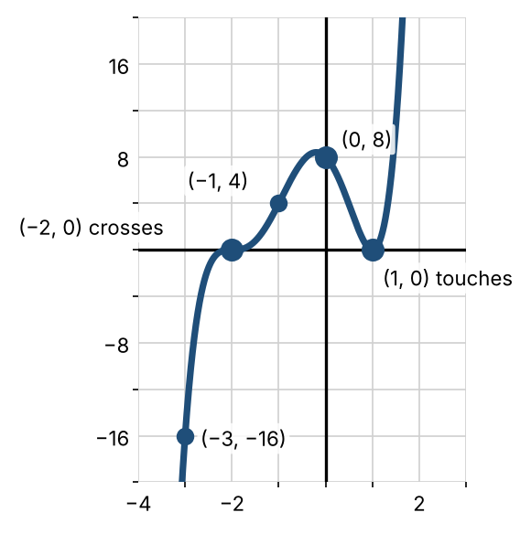

Practice
Use end behavior, intercepts, multiplicity, and test points to sketch each graph.
a. $P(x)={(x+3)}^{2}{(x−1)}^{3}$  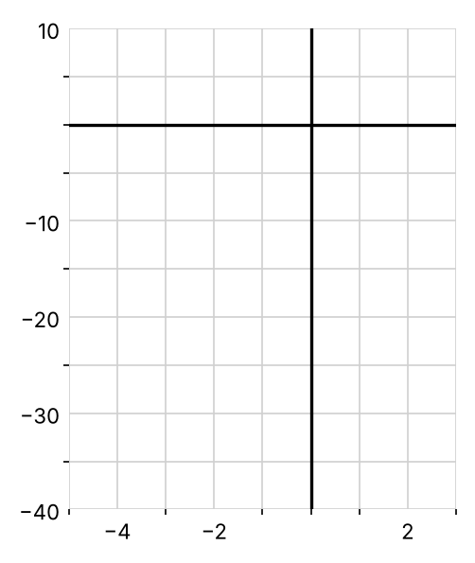 | b. $P(x)=x^{3}+2x^{2}−8x$  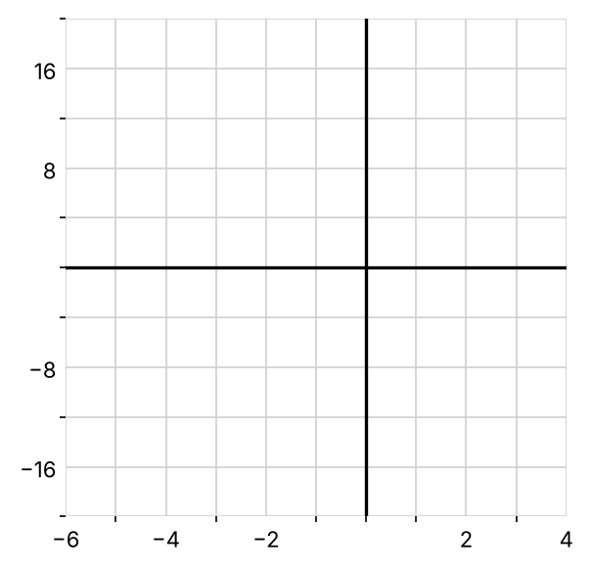 | c. $P(x)=−x^{2}(x−3)$  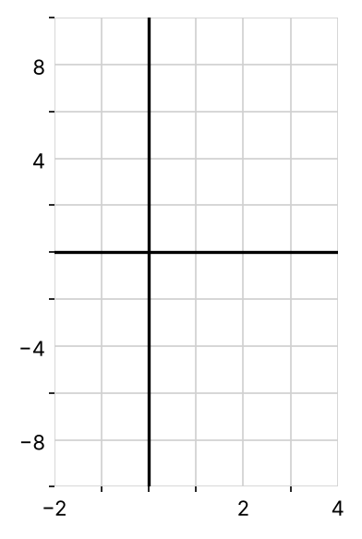

Exit check
1. Find the vertex of $f(x)=x^{2}−6x+11$ and its minimum value.

2. Describe the end behavior of $P(x)=−4x^{3}+x−1$.

3. List the zeros of $P(x)={(x−5)}^{2}(x+1)$ with their multiplicities.

